CITIZEN’S SUMMARY
of the Annual Implementation Report for 2018
regarding the Romania – Bulgaria Interreg V-A Programme

Results
Results are already visible throughout the eligible area. Projects dedicated to modernization of the road and fluvial infrastructure, promotion and culture heritage (including tourism), management of risks in the eligible area, labour mobility and equal chances as well as increasing administrative capacity of public institutions in the eligible area are changing the life of people in the cross-border area: https://www.youtube.com/watch?v=TfCNMH58rsU&feature=youtu.be&fbclid=IwAR188dPVwrmO0KR3xwC6yheBV_bzcT1K72Yc2yrCENOhUTXe1dV4_fIP6Fc
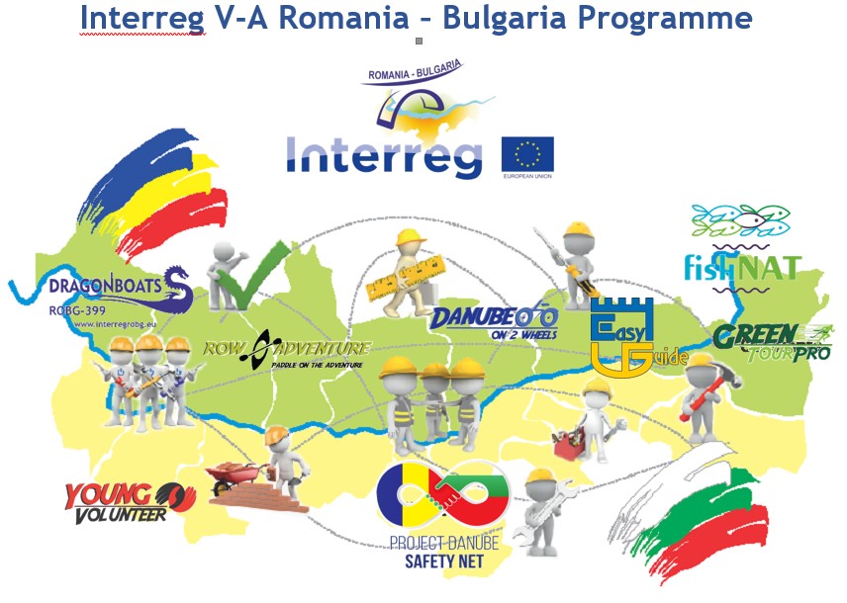
- We have a beautiful border
32 new touristic products/services promote the natural and cultural attractions in the area. To see our attractions and to plan your holidays you can choose from a large variety of options: http://www.impact-tour.eu, http://danubelimes-robg.eu, http://ecotourism-robg.eu/, https://greenschooleducation.eu/, http://balloonadventure.eu/en/, http://robgtraditions.com/en/, http://mehedinti-vidin.ro/en/, http://heritagerobg.eu/, http://prunepentrugunoi.ro/, https://audiotravelguide.ro/en/.
6 mobile apps to make it easier for everyone to discover out beautiful area are now available in GooglePlay store and AppStore (“Danube Old Rich History” – Historical Sites in RO-BG the cross-border region; “Ecotourism” – promoting protected natural heritage within the cross-border region Romania-Bulgaria; “Impact-tour”-providing information on tourist services, “Nature in hand” presenting tourist /natural/ sites and destinations in the regions of Montana, Vidin, Vratza and Pleven in Bulgaria and Dolj, Olt, and Mehedinti in Romania through GPS navigation , “Danube Limes” providing information on roman heritage in the cross border area).
- Taking good care of nature
11 protected NATURA 2000 areas developed management tools contributing to improvement of the conservation status of 27,058 hectares of habitats (https://gnm.ro/incolab/ and http://prunepentrugunoi.ro/.).

- Keeping you safe
Education campaigns for prevention of risks and risk management were developed (http://www.safe-schools.eu/, www.project-code.eu)
Increase of the capabilities and interoperability for joint RO-BG cross-border first responder intervention to chemical-biological-radiological-nuclear-high yield explosive emergencies was ensured (http://www.jerome-robg.eu/)
A joint rapid intervention force to CBRN emergencies on the Danube River within the structures of emergency authorities from the cross-border area was created (http://www.demersys-robg.eu/).
- Working together
Numerous events and trainings related to the mobility of the cross border labour market and improvement of access for disadvantaged categories to jobs were organized by our projects (http://robg-united.eu/, www.bgromobility.eu, http://societyforallages.ro/en/, https://juriscbp.ro/, https://jobease.eu/, www.mobility-web.eu, http://eco-bs.eu http://mobgiru.eu, https://capability-acces.eu/, https://www.sem-centres.eu/en/) .

Public institutions
Exchanges of good practices and coordination of the public institutions are promoted by our projects. Thus, the integration of minorities and disadvantaged groups is promoted starting from school, by encouraging and supporting them to continue their education (Follow the link: http://robg173.eu to learn about two schools and their dedication: Hristo Smirnenski" Primary school from General Toshevo and school "Adrian V. Radulescu" of the city Murfatlar). Also, looking to the future, we are educating our students in entrepreneurship field with the help of new trained teachers and an updated curricula (www.ro-bg.eu). In the same time, our projects are guiding and counseling the pupils to choose their careers based on their preferences and skills (http://proiectlearn.ro/).
- Connected
7.06 km of upgraded road is now connecting the people from Leviski with their neighbors and more to come as public procurement procedures for modernization of almost 123 km have been launched.

Our world in figures!
156 project (228.28 mil. Euro) under implementation, 40 already finalized
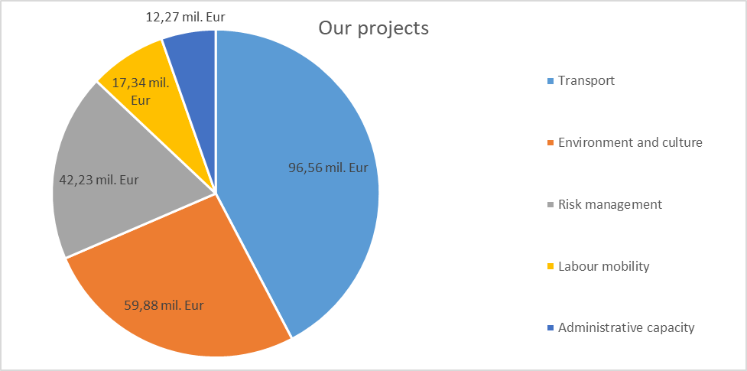
Keep an eye on us!

https://www.facebook.com/RomaniaBulgariaCbcProgramme?fref=ts
https://twitter.com/ROBGProgramme
https://www.youtube.com/channel/UCtgRgCcdOK5D2ZsBJrMPXew/videos
https://www.instagram.com/interregrobg/

